1. **INNER JOIN:**

**SELECT O.`customer_id`,P.`Name`,i.`name` from ITEM I inner join orders O on O.`item_id`=i.`item_id` INNER join PERSON P on O.`customer_id`=P.`customer_id`;**

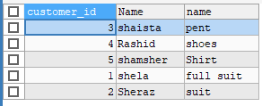

**2.LEFT JOIN:**

**SELECT O.`customer_id`,P.`Name`,i.`name` product from ITEM I left join orders O on O.`item_id`=i.`item_id` left join PERSON P on O.`customer_id`=P.`customer_id`;**

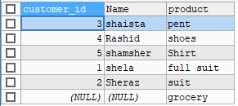

**3.RIGHT JOIN**

**SELECT O.`customer_id`,P.`Name`,i.`name` product from ITEM I right join orders O on O.`item_id`=i.`item_id` right join PERSON P on O.`customer_id`=P.`customer_id`;**

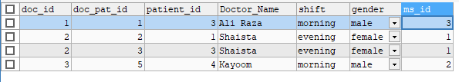

**4.NATURAL JOIN:**

**SELECT * from orders O natural join PERSON P;**

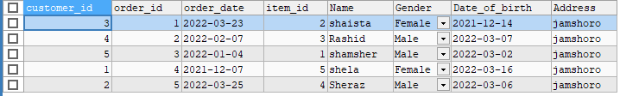

**5.CROSS JOIN:**

**SELECT * from orders O cross join PERSON P on O.`customer_id`=P.`customer_id` ;**

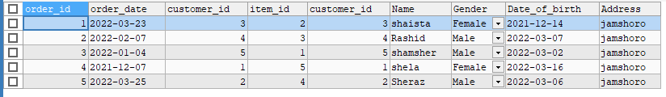

**6.EQUIJOINS**

**1.** **SELECT * from orders O join PERSON P where O.`customer_id`=P.`customer_id` and gender='male' ;**

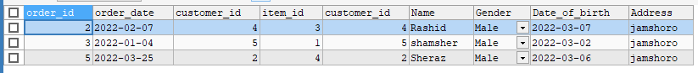

1. **SELECT * from orders O join item i using(item_id) ;**

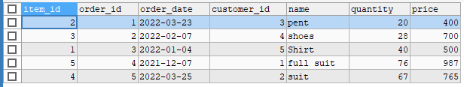

**3.** **SELECT o.`customer_id`,p.`Name`,p.`Gender`,o.`order_date`,p.`Address` ,i.`name` product,i.`price` from orders O join PERSON P on O.`customer_id`=P.`customer_id` join item i on O.`item_id`=i.`item_id` order by o.`customer_id` ;**

